A partnership with a lot of potential
Leifeld Metal Spinning joins Nihon Spindle Manufacturing Group

Leifeld Metal Spinning and Nihon Spindle Manufacturing - two of the industry’s important companies for the development and production of spinning machines and flow-forming machines in non-cutting, chipless metal forming - are joining forces. This strategic integration will strengthen the international competitiveness of both companies, which optimally complement each other with their technologies and market coverage. The brands and company locations will remain unaffected.

With effect from May 29th, 2020, Nihon Spindle Manufacturing Co., Ltd. has acquired all the shares of Leifeld Metal Spinning AG. The previous owner is the investor Dr. Georg Kofler. He had been in talks about a possible acquisition with Nihon Spindle, a subsidiary of the Japanese conglomerate Sumitomo Heavy Industries Group, since the beginning of last year. The closing has now taken place, after both parties signed the share purchase agreement in October 2019.
Nihon Spindle Manufacturing was founded in 1918 and has its roots in the manufacturing of spindles for the textile industry. Today, the company is known as one of the leading spinning and flow forming machine manufacturers worldwide. The main business areas of the company are industrial machinery, HVAC (Heating, Ventilation and Air Conditioning), as well as environmental technology. "There is no better partner for us than Nihon Spindle Manufacturing," explains Oliver Reimann, CEO of Leifeld Metal Spinning AG. "I am convinced that this is the right way to lead Nihon Spindle and Leifeld to further growth. Our customers and our employees will both benefit from this collaboration. We are very pleased to combine the strengths of both companies in order to be able to keep on offering our customers new and innovative solutions in the future, and thus clear added value."
Leifeld Metal Spinning develops and manufactures machine tools for non-cutting, chipless metal forming, and is active worldwide in the automotive industry, aerospace technology, the energy industry, as well as in various consumer and industrial goods sectors. "With Leifeld, we gain an experienced partner with valuable know-how and an exemplary corporate culture. Leifeld's long tradition provides a stable foundation and a high level of innovative strength, which we now want to reinforce and expand together," emphasizes Hiroshi Arito, President of Nihon Spindle Manufacturing Co., Ltd.
Dr. Kofler was the owner and shareholder of Leifeld Metal Spinning AG for twelve years and would like to focus on the media industry once again: "I look back on an instructive time and a particularly successful investment with great affection," he explains. "My major thanks and respect go to the employees of Leifeld Metal Spinning, who have built up the company's global technological leadership with their expertise and passionate commitment. I am happy to put Leifeld into competent hands and could not imagine a better partner for the company than Nihon Spindle Manufacturing."

3,088 characters incl. blanks

Meta-Title: Leifeld Metal Spinning becomes more international

Meta-Description: Two specialists in non-cutting, chipless metal forming are joining forces: Nihon Spindle Manufacturing acquires all the shares of Leifeld Metal Spinning.

Keywords: Leifeld Metal Spinning; Nihon Spindle Manufacturing; Sumitomo Heavy Industries; Closing; non-cutting, chipless metal forming

Captions:
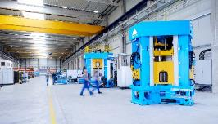
Picture 1: Leifeld Metal Spinning builds machine tools that deliver powerful maximum performance for non-cutting, chipless metal forming.

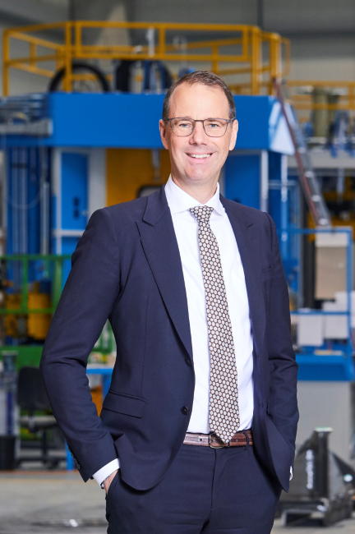
Picture 2: "I am convinced that this is the right way to lead Nihon Spindle and Leifeld to further growth," emphasizes Oliver Reimann, CEO of Leifeld Metal Spinning AG.

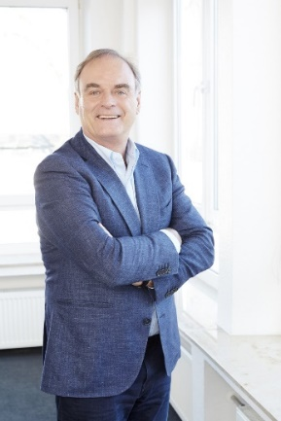
Picture 3: Dr. Georg Kofler was the owner and shareholder of Leifeld Metal Spinning AG for twelve years.
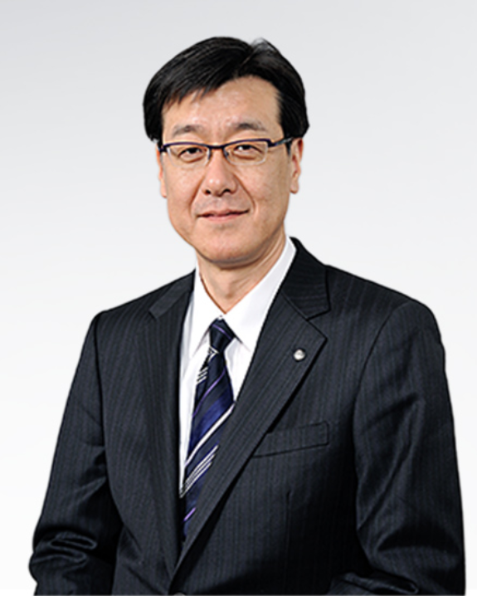
Picture 4: Leifeld's long tradition provides a stable foundation and a high level of innovative strength, which we now want to reinforce and expand together," explains Hiroshi Arito, President of Nihon Spindle Manufacturing Co, Ltd.
Photo credits: Leifeld Metal Spinning AG

You can download the high-resolution pictures here.

About Leifeld Metal Spinning:
Leifeld Metal Spinning AG develops, manufactures, and distributes machine tools for non-cutting, chipless metal forming. More than 200 employees work at locations in Germany, the USA, China and Russia. The company is present in all the major global markets due to numerous branches on all the continents. The core industries are automotive, aerospace, energy, and industrial applications. The production site and headquarters are located in Ahlen, Germany.
The product range includes machine tools for the manufacture of various intermediate or end products. The machines are equipped with multifaceted automation solutions and can be individually adapted to suit the customer's requirements. Over more than 125 years of business, Leifeld Metal Spinning has manufactured over 6,125 machines and delivered them to 60 countries.
Leifeld Metal Spinning also supports its customers with a comprehensive range of services which cover the entire product lifecycle. The company offers all the services - ranging from research & development, technical service, spare parts procurement, consulting, and training to the retrofitting of second-hand machines. Leifeld develops new processes, technologies, and products, and has filed for patents on more than 140 inventions to date.
For more information, please visit: www.leifeldms.com
About Nihon Spindle Manufacturing:
Nihon Spindle Manufacturing Co., Ltd. is a Japanese manufacturer with its headquarters in Amagasaki, in the Hyogo Prefecture. The company is a subsidiary of the Sumitomo Heavy Industries Group since 2007. Nihon Spindle Manufacturing operates in three business fields. The industrial machinery business including spinning and flow forming machines contributes to various industries by providing unique technologies, the environmental business promotes environmental protection and recycling technologies, and the HVAC business delivers products and systems to create a comfortable space and to optimize production processes. In 2018, the company generated a turnover of more than 150 million euros with about 650 employees worldwide.
For more information, please visit: http://www.spindle.co.jp/en
About Sumitomo Heavy Industries:
Since its origin in 1888 as a machine repair shop at the Besshi Copper Mine Sumitomo Heavy Industries (SHI) looks back on a long tradition that has been based on the extraction, processing and trading of copper. Over the centuries, the Japanese mechanical engineering company with its headquarters in Tokyo has grown into a globally active group of companies, which is present worldwide with numerous group companies, offices, production facilities and development centers. Sumitomo Heavy Industries is active in numerous industries, so the product portfolio is correspondingly diverse. The systems and machines of the Japanese company are used in building technology, in the transport sector - including on- and off-highways, railways and ships - as well as in the medical technology. Sumitomo Heavy Industries also manufactures equipment for the semiconductor industry and the production of liquid crystals.
For more information, please visit: www.shi.co.jp/english

Press contact at Leifeld Metal Spinning:
Mrs. Beate Hiltrop, Head of Marketing
+ 49 (0) 2382 96607 309
press-office@leifeldms.com
www.leifeldms.com

Leifeld Metal Spinning AG, Feldstr. 2-20, 59229 Ahlen, Germany

Contact PR agency:
Mrs. Kirsten Ludwig
+ 49 (0) 711 9454161 20
klu@a1kommunikation.de
www.a1kommunikation.de

a1kommunikation Schweizer GmbH, Oberdorfstraße 31 A, 70794 Filderstadt, Germany

